Minutes of the Whitehorse Canoe Club Committee Meeting

October 2025

Details: 8th October 2025
Present: David O, Alison, Linton, Des, Scott
Apologies: David G, Sean, Geoff, Jimmy

Meeting Opened: 7:50pm

Topic | Content | Individuals Assigned
Acknowledgement to Country | Club president Alison Boys read the Acknowledgement to Country statement to open the meeting.
Previous minutes | Committee Meeting Minutes 8/09/2025 – Approved
Treasurers Report | Current Balance: $11,384.64 as of 7/10/2025 | David O
 | $10,740 in the Sandhurst Account and $687 in the Trading Account.  (Full report attached) | David O
Trips since last meeting | - Friends of the Mitta 27-28/09/25
Future Trips | - River TBD 19/10/25 Scott  - Family paddle River TBD 26/10/25 Maddy  - Snowy River 1-4/11/25  - Extended Snowy River 30/10/25 to 4/11/25
New members | Membership update since last meeting 8th September 2025  current membership is 81 members no new members since last meeting. | Geoff B
Correspondence | Paddle Australia equipment Insurance. (Des to forward to club members).
Old Business / Outstanding tasks / Ongoing | Child safe clubs / national integrity. By exception. We agree to commit to the child safe national integrity framework.  No reportable incidence. | David G  Alison
 | Grants for skills development. By exception. None that apply to us. | Alison
 | PV are generally happy with WHCC processes.
 | Asset Tracking sheet in progress.  Continue to update as required – Up to date.  Reminder.  Frame not with raft. | Linton
 | Discussed promoting club and white-water kayaking.  Set date for dedicated recruiting focused meeting. | David G Alison  Jimmy
 | Possible Pack raft purchase.
 | Beginner boats
 | Playboat come and try it day.
 | Update map disclaimer (Requires lawyer). | David O.
 | Write enquiry letter to insurance company about cover. | David O.
 | Subsidise skills improvement courses.  Enquire with Mick Ramsay and Sean Smith, re possible course  Enquire re Tasmania course | David G Alison
 | Locate Old WHCC Newsletters  Check whether newsletters are already in the electronic files | Alison  Linton
 | Post links to new georeferenced maps on Facebook. | David O
 | New improved maps on Avanza insert links. To be uploaded to the website. Notify members to review. | Alison  David O
 | Meeting with Paddle Victoria | Allison
 | Email list management
 | Regular meeting – day and format
 | Communication through Just Go
 | 30-day Trial membership
 | Single day ad-hoc membership | Allison
 | Snowy River trip to be the test bed for registering for paddles via Just Go. | Des
New Business
 | Rolling session Sandringham at the beach Januaryish
 | Insurance enquiries ongoing.
 | Get rid of one of the Facebook pages.
 | Make email list more public.
 | Purchase new Groover approved.
 | ATO submission NFP Income tax exemption.

Note: All items from previous meeting minutes which are not listed in the above minutes are deemed to be resolved and therefore closed and not included in the above minutes.

Meeting Closed: 8:30pm
Next Meeting: Zoom 11th November 2025
7pm for meal and 8pm for meeting at Mitcham Hotel

WHITEHORSE CANOE CLUB

To: Committee

Date: 6 October 2025

Subject: Treasurer Report

From: David Osborn

Finances
Please find below a Profit & Loss for the period 1 July 2025 to 1 October 2025 and a Balance Sheet as at 1 October 2025.
My comments are:
- Whitehorse is in a strong position with $10,740 in the Sandhurst Account and $687 in the Trading Account.
- There are no debtors or creditors.
- The Profit & Loss account has been compared to a budget and forecast updated as at 1 October 2025. The updates reflect the actual cost YTD on various items.
- There is no forecast planned capital purchases but the Committee is reviewing purchase of a pack raft as club equipment.
- I am forecasting $350 for purchase of NatMap base maps to update Whitehorse river maps.
- The current forecast surplus for the year is $1,120.
- There has been no major expenditure since 1 July 2025.

Membership
- I am unclear who is reporting on membership numbers.

Profit & Loss Account

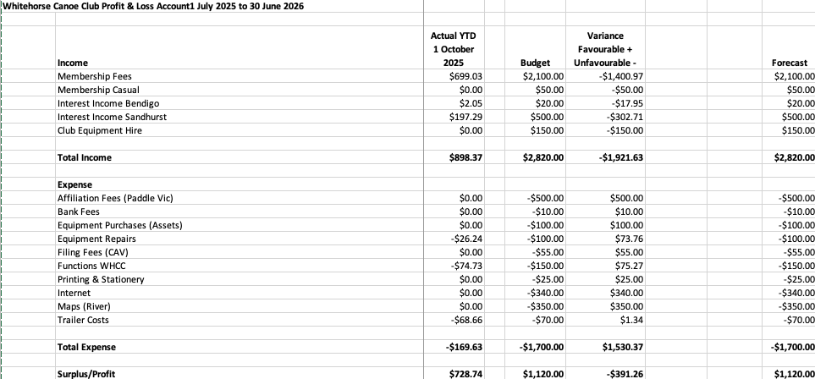

Balance Sheet
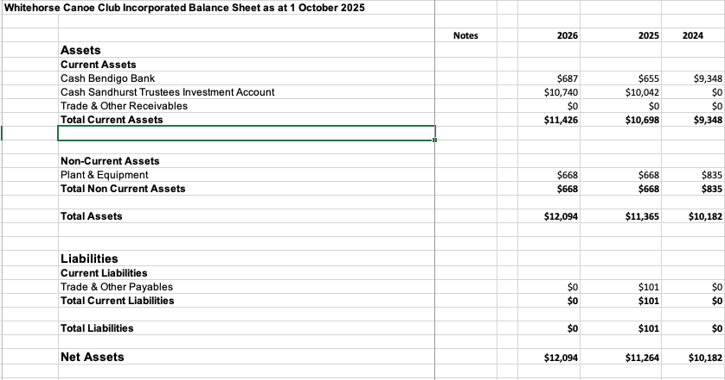

Other Matters:

- Nil

